NETWORK ARCHITECTURE, IP ADDRESS PLANNING, AND ROUTING PROTOCOLS PROJECT REPORT

DATE: 15TH MARCH 2024

# **PROJECT OVERVIEW:**

This paper describes lab activities carried out on a given network architecture, focusing on IPv4 and IPv6 addressing, routing protocols, and VLAN configuration in the GNS3 virtual environment using Cisco 7200 routers and Cisco 3725 Ethernet switches. We planned efficient IP addressing schemes, including loopback interfaces, and configured OSPF, RIP, and BGP protocols to better comprehend dynamic routing mechanisms and enhance network performance. VLAN configuration focused on traffic segmentation and isolation to increase network security, while packet capture exercises provided practical understanding of protocol behavior. Through hands-on experimentation, we learned critical skills in network design, administration, and troubleshooting, allowing us to gain an understanding of essential networking fundamentals required for real-world applications.

**TABLE OF CONTENTS**

**REPORT OVERVIEW:** 2

**1.** **CHAPTER 1: TASK 1 (IPv4)** 5

**1.1.** **Introduction** 5

**1.2.** **Topology** 5

**1.3.** **Interface Addressing** 5

**1.3.1.** **NextTel (AS 20001)** 6

**1.3.2.** **TeleStar (AS 4010)** 11

**1.3.3.** **Level 3** 13

**1.4.** **Routing Protocols Configurations** 14

**1.4.1.** **Routing Information Protocol (RIP)** 14

**1.4.2.** **Open Shortest Path First (OSPF)** 15

**1.4.3.** **Border Gateway Protocol (BGP)** 16

**1.4.4.** **Static Null Configuration** 17

**1.5.** **VLAN CONFIGURATION** 18

**1.6.** **GigaEthernet Link Preference Setting** 21

**1.7.** **OSPF Packet Capture** 22

**2.** **CHAPTER 2: TASK 2 (IPV6)** 23

**2.1.** **Introduction** 23

**2.2.** **Topology Visualization** 23

**2.3.** **IPv6 Address Planning** 24

**2.3.1.** **Removal of IPv4 Addresses** 24

**2.3.2.** **Assigning IPv6 Addresses** 25

**2.3.3.** **Level 3** 26

**2.4.** **IPv6 Routing Protocol Configurations** 27

**2.4.1.** **Open Shortest Path First** 27

**2.4.2.** **Border Gateway Protocol** 30

**2.5.** **Tunneling** 31

Table of Tables

Table 1: NextTel IP address planning 7

Table 2: TeleStar IP Addresss Palnning 12

Table 3: Address planning for Level 3 router 13

Table 4: IPv6 Address Planning 25

Table of Figures

Figure 1: Network Topology 5

Figure 2: Topology showing interfaces 6

Figure 3: Internal Interface Addresses of Router N1 after configuration 8

Figure 4: External Interface Address of N1 after configuration 9

Figure 5: Interface Address of N2 towards Level 3 after configuration 10

Figure 6: Loopback Addresses of N2 after configuration 11

Figure 7: T3 Interface Addresses for Internal, External & Loopbacks 12

Figure 8: Address of interface toward Level 3 13

Figure 9: Level 3 Router Interface and Loopback Addresses 14

Figure 10: Routing Information Protocol (RIP) Database for Router N2 15

Figure 11: OSPF neighbors for Router T3 after OSPF configuration 16

Figure 12: Next Hop BGP information 17

Figure 13: Static Null0 configuration 18

Figure 14: Ethernet Switch Configuration 19

Figure 15: VLAN ping test 20

Figure 16: Setting GigaEthernet to be preferred over FastEthernet 21

Figure 17: Wireshark OSPF Capture 22

Figure 18: IPv6 Topology Visualization 23

Figure 19: Removal of IPv4 Addresses 24

Figure 20: IPv6 Interface Address Configuration for Router T1 26

Figure 21: Level 3 Router, R10, Interface Address and Loopback Configuration 26

Figure 22: OSPF Configuration for Router T3 27

Figure 23: Router, T3, OSPF neighbors and ping test 28

Figure 24: Routing Table Showing OSPF Address for T3 28

Figure 25: OSPF GigaEthernet Link Preference Configuration 29

Figure 26: GigaEthernet and FastEthernet Link Costs 29

Figure 27: BGP Next Hop and Neighbor information 31

Figure 28: Ping and Traceroute test for tunneling on PC 1 32

Figure 29: Ping and Traceroute test for tunneling at PC4 32

# **CHAPTER 1: TASK 1 (IPv4)**

## **Introduction**

IPv4, the foundational protocol of modern networking, assigns unique numerical addresses to devices, enabling efficient data routing across the Internet. With its recognizable dotted-decimal notation, IPv4 has facilitated the explosive growth of connected devices, from personal computers to IoT gadgets. Despite its widespread use, IPv4 faces challenges such as address exhaustion, prompting the development of IPv6 as a successor protocol. Nevertheless, IPv4 continues to play a crucial role in global networking infrastructure, facilitating seamless communication across diverse platforms and applications.

## **Topology**

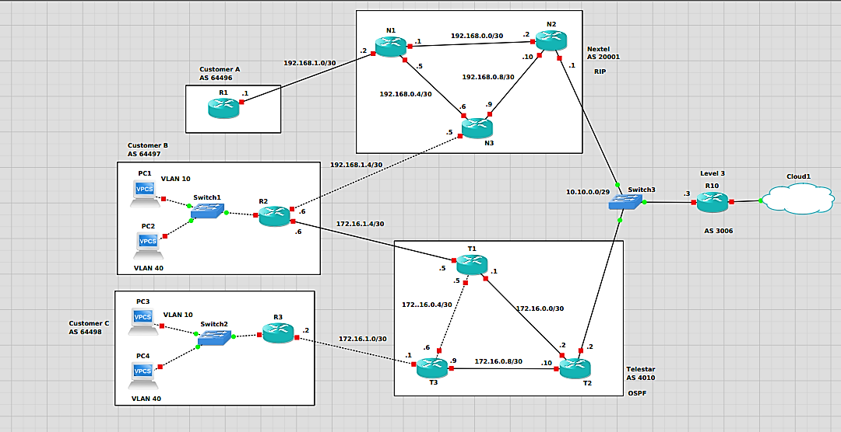

Figure 1: Network Topology

*Figure 1* shows the topology of the network provided in the lab manual. This topology was obtained by importing and placing the Cisco 7200 Routers and the Ethernet Switches on the GNS3 workspace to emulate the design provided.

## **Interface Addressing**

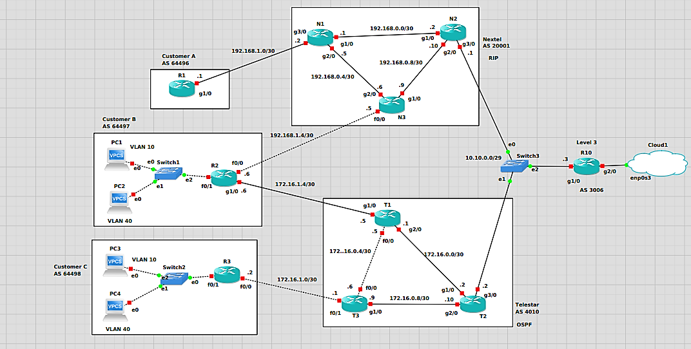

Figure 2: Topology showing interfaces

For a given router, there are a set of interfaces associated with it. To establish a link between any two devices (routers, PC, or switches) an interface must be selected on the devices at the opposite ends of the link. For the purposes of this lab, there are two possible links: FastEthernet and GigaEthernet. When connecting a link to the router, you select one of these link types on at the router (ex. GigaEthernet 1/0).

After a successful link has been established between the two routers, the routers’ interfaces take the form g0/0, g1/0, etc. for gigaEthernet, and f0/0, f0/1, f1/0, etc. for fastEthernet links.

In *Figure 2* above, the interfaces associated with each link can be seen at the router sides.

### **NextTel (AS 20001)**

From *Figure 1*, we observe that NextTel has the following routers: N1, N2, and N3. From the project instructions, NextTel was assigned an overall IP address range of 192.168.0.0/16. Amongst this range, NextTel uses 192.168.0.0/24 for internal addressing, 192.168.1.0/24 for external addressing, 192.168.2.0/24 for loopback interfaces and 10.10.0.0/24 for links towards Level 3.

|  |  |  |  |  |
| --- | --- | --- | --- | --- |
| **Autonomous System** | **Routers/hosts** | **Interface** | **IP address** | **Subnet Mask** |
| Nextel AS 20001 | N1 | Loopback0 | 192.168.2.1 | 255.255.255.255 |
| Loopback1 | 192.168.2.2 | 255.255.255.255 |
| g1/0 | 192.168.0.1 | 255.255.255.252 |
| g2/0 | 192.168.0.5 | 255.255.255.252 |
| g3/0 | 192.168.1.2 | 255.255.255.252 |
| N2 | Loopback0 | 192.168.2.3 | 255.255.255.255 |
| Loopback1 | 192.168.2.4 | 255.255.255.255 |
| g1/0 | 192.168.0.2 | 255.255.255.252 |
| g2/0 | 192.168.0.10 | 255.255.255.252 |
| g3/0 | 10.10.0.1 | 255.255.255.248 |
| N3 | Loopback0 | 192.168.2.5 | 255.255.255.255 |
| Loopback1 | 192.168.2.6 | 255.255.255.255 |
| g1/0 | 192.168.0.9 | 255.255.255.252 |
| g2/0 | 192.168.0.6 | 255.255.255.252 |
| f0/0 | 192.168.1.5 | 255.255.255.252 |

Table 1: NextTel IP address planning

Table 1 shows the IP addresses associated with the interfaces of each router in NextTel.

#### **Internal Addressing**

From the NextTel AS in Figure 1, it is observed that there are three internal subnets, with two interfaces each. Each of these interfaces will have an IP address. The subnet also reserves two IP addresses for the network ID and broadcasting. Given that there are two interfaces per subnet and two addresses reserved for network ID and broadcast, we could employ a /30 network for NextTel’s internal subnets. A /30 network is suitable because it avoids wastage of IP addresses.

Below are the steps taken to configure the router to know the IP address of the router’s interfaces. In this example one of NextTel’s router interfaces, N1 g1/0, is used.

**Configuration Commands:**

*config t*

*interface g1/0*

*ip address 192.168.0.1 255.255.255.252*

*no sh*

*exit*

*end*

*wr*

*<config t>* is used to set up the configuration terminal. *<interface g1/0>* is used to obtain the interface configuration terminal so that every subsequent command is applied for that interface. <*ip address 192.168.0.1 255.255.255.252>* is used to directly state to the router that the address, 192.168.0.1 with subnet mask 255.255.255.252, should be used for interface g1/0. *<no sh>* is used to prevent the interface from shutting down. *<exit>* is used to exit the specific interface we’re currently working in, g1/0. *<end>* is used to leave the configuration terminal. *<wr>* is used to write (save) our changes to the router.

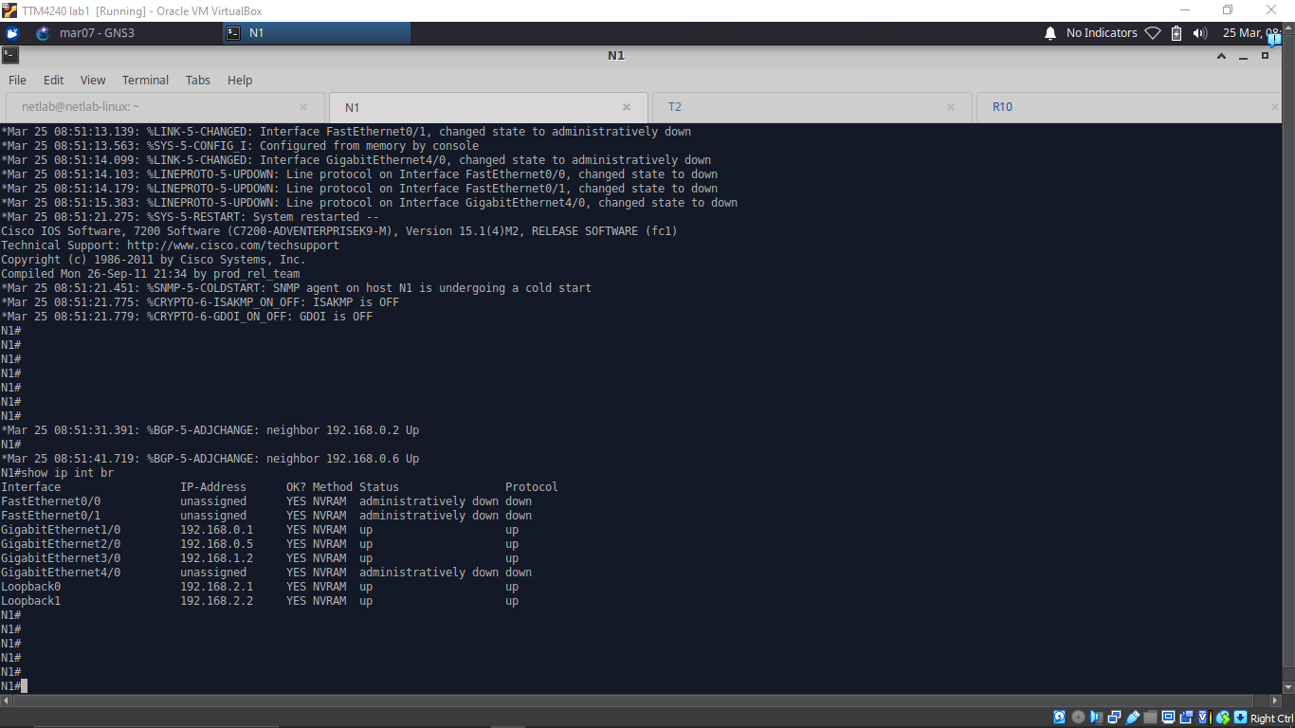

Figure 3: Internal Interface Addresses of Router N1 after configuration

#### External Addressing

External addresses are applied to external links. External links are links that starts in one AS and ends in another AS. From the manual 192.168.1.0/24 should be applied for NextTel’s external links.

For the external link between NextTel (AS 20001) and Customer A (AS 64496) and the link between NextTel and Customer B (AS 64497), there are only two interfaces for each subnet. Therefore a similar concept for the internal addressing is applied, leaving a /30 network for these external links.

**Configuration Commands Example**

*config t*

*interface g3/0*

*ip address 192.168.1.2 255.255.255.252*

*no sh*

*exit*

*end*

*wr*



Figure 4: External Interface Address of N1 after configuration

#### Level 3

From the instructions, links toward level 3 should be assigned IP address in the range 10.10.0.0/24. However, for proper address assignments and to avoid wastage of IPv4 addresses, a /29 subnet can be selected. /29 is a good option because there are three interfaces associated with the switch at level 3. Therefore for efficient planning, it is best to pick a prefix that can house at least 5 interfaces (accounting for network ID and broadcast). /29 gives us 23 (8) possible hosts. Therefore the /29 is selected.

Configuration for the Level 3 routers follow similar commands as seen previously, however, the interfaces are modified to the level three interface for a given router and the IP address is also modified. Because we’re using a /29 network, the subnet mask becomes 255.255.255.248. This subnet mask is used when performing the *<ip address>* command.

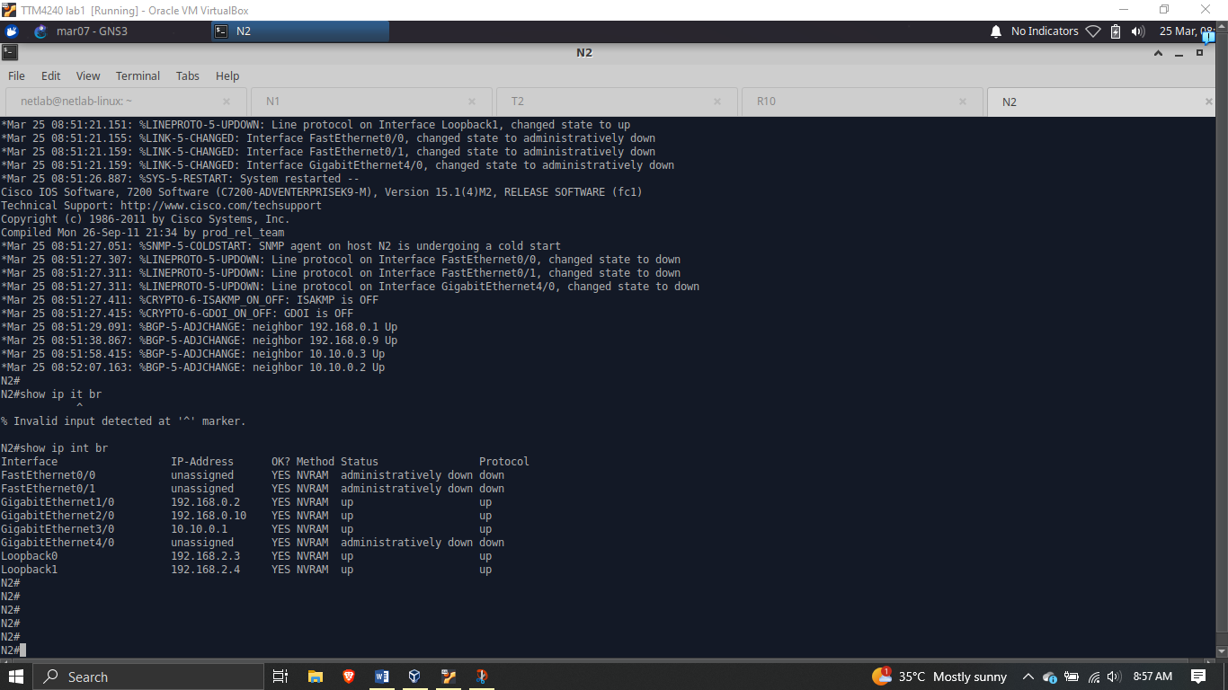

Figure 5: Interface Address of N2 towards Level 3 after configuration

#### Loopbacks

Each router should have two loopback interfaces, except the level 3 router. For NextTel’s routers, an IP address range of 192.168.2.0/24 should be applied. Loopbacks should have a subnet mask of 255.255.255.255. Table 1 contains the loopback IP addresses provided for each router.

The commands below is an example commands to follow when configuring loopback interfaces. The example is performed for router N1. For loopback 0, *<loop0>* is used, and for loopback 1, *<loop1>* is used.

*config t*

*interface loop0*

*ip address 192.168.2.1 255.255.255.255*

*no sh*

*exit*

*end*

*wr*



Figure 6: Loopback Addresses of N2 after configuration

### **TeleStar (AS 4010)**

From *Figure 1*, we observe that TeleStar has the following routers: T1, T2, and T3. From the project instructions, TeleStar was assigned an overall IP address range of 172.16.0.0/16. Amongst this range, TeleStar uses 172.16.0.0/24 for internal addressing, 172.16.1.0/24 for external addressing, 172.16.2.0/24 for loopback interfaces and 10.10.0.0/24 for links towards Level 3.

|  |  |  |  |  |
| --- | --- | --- | --- | --- |
| **Autonomous  Systems** | **Routers/hosts** | **Interface** | **IP address** | **Subnet Mask** |
| Telstar  AS 4010 | T1 | Loopback0 | 172.16.2.1 | 255.255.255.255 |
| Loopback1 | 172.16.2.2 | 255.255.255.255 |
| g1/0 | 172.16.1.5 | 255.255.255.252 |
| g2/0 | 172.16.0.1 | 255.255.255.252 |
| f0/0 | 172.16.0.5 | 255.255.255.252 |
| T2 | Loopback0 | 172.16.2.3 | 255.255.255.255 |
| Loopback1 | 172.16.2.4 | 255.255.255.255 |
| g1/0 | 172.16.0.2 | 255.255.255.252 |
| g2/0 | 172.16.0.10 | 255.255.255.252 |
| g3/0 | 10.10.0.2 | 255.255.255.248 |
| T3 | Loopback0 | 172.16.2.5 | 255.255.255.255 |
| Loopback1 | 172.16.2.6 | 255.255.255.255 |
| g1/0 | 172.16.0.9 | 255.255.255.252 |
| f0/0 | 172.16.0.6 | 255.255.255.252 |
| f0/1 | 172.16.1.1 | 255.255.255.252 |

Table 2: TeleStar IP Addresss Palnning

Table 2 shows the IP addresses associated with the interfaces of each router in TeleStar.

#### Internal, External, Loopbacks, & Level 3

A similar rational from the address planning of NextTel is applied here. In TeleStar’s internal and external (except level 3) network, a new range of /30 can be used per subnet since each subnet consists of only two interfaces.

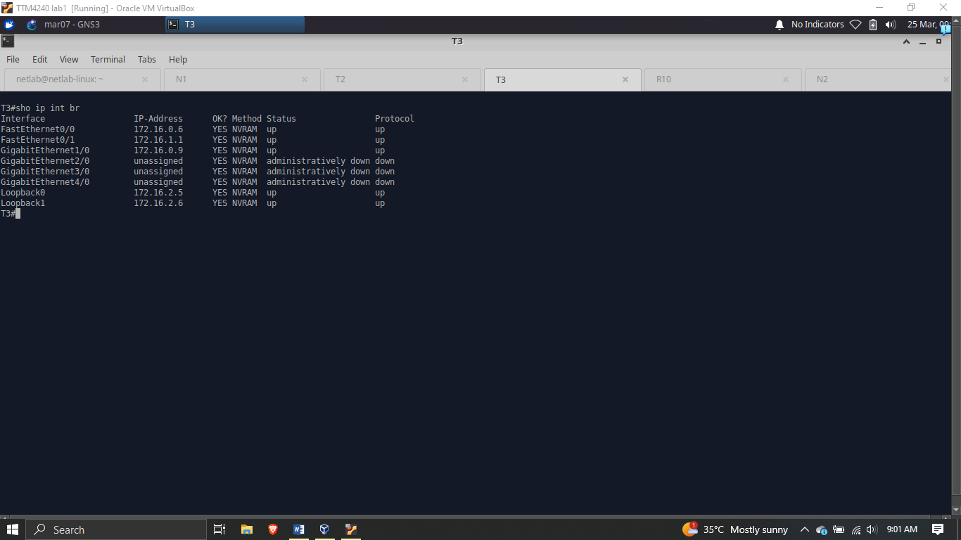

Figure 7: T3 Interface Addresses for Internal, External & Loopbacks

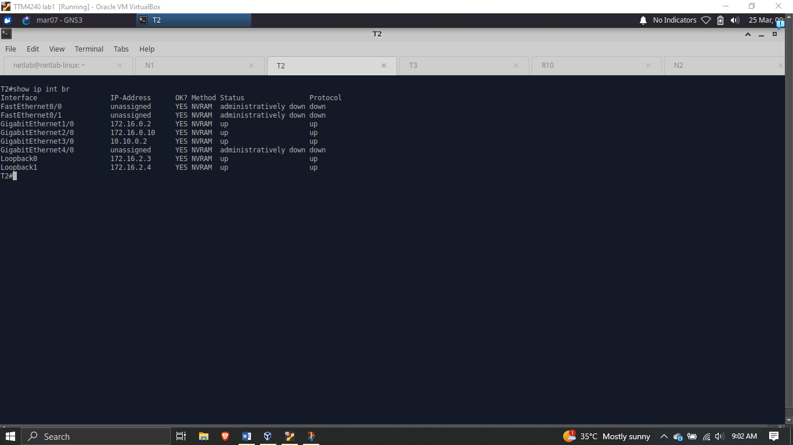

Figure 8: Address of interface toward Level 3

### **Level 3**

The interface address for level 3 inherits from the /29 subnet created.

|  |  |  |  |  |
| --- | --- | --- | --- | --- |
| Level 3 AS 4010 | R10 | g1/0 | 10.10.0.3 | 255.255.255.248 |
| g2/0 |  |  |
| Loopback0 | 10.10.1.1 | 255.255.255.255 |

Table 3: Address planning for Level 3 router

The table shows the level 3 router’s interface, g1/0, address and the loopback address.

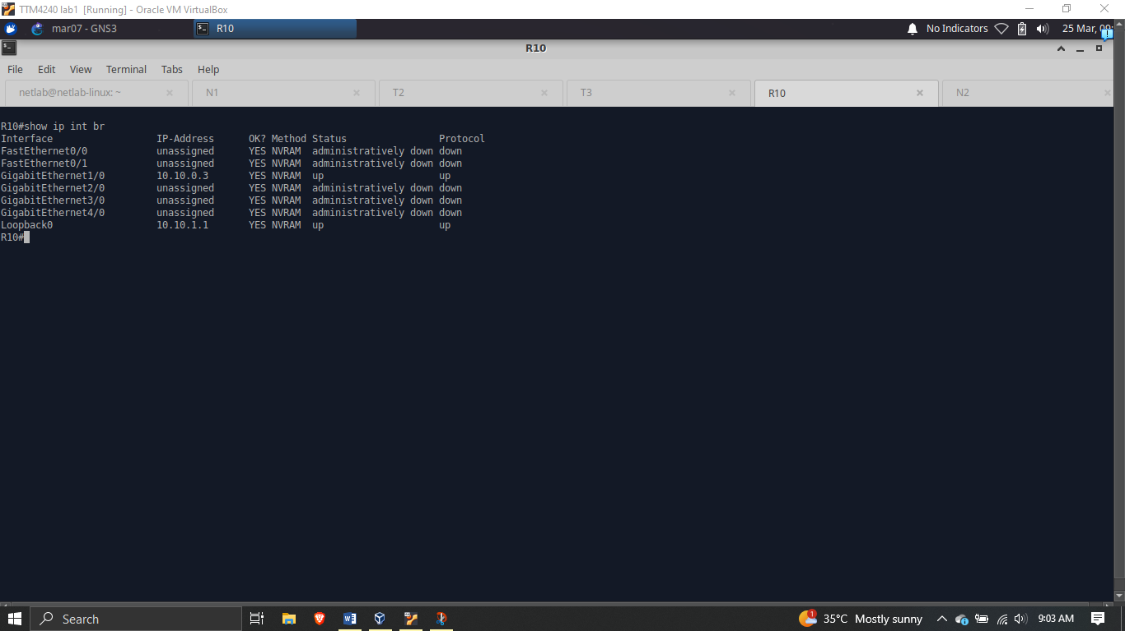

Figure 9: Level 3 Router Interface and Loopback Addresses

## **Routing Protocols Configurations**

### **Routing Information Protocol (RIP)**

From the lab instructions, RIP is to be configured for NextTel’s network. RIP is an Internal Gateway Protocol (IGP), it only applies to the internal network.

In NextTel’s internal network, there are two subnets for every router. The ID’s for the two subnets are noted and used in the configuration of the protocol into the router.

To configure the Routing Information Protocol (RIP), the following commands can be followed.

1. *conf t*
2. *router rip*
3. *network <subnet 1 network ID>*
4. *network <subnet 2 network ID>*
5. *end*
6. *wr*

*<conf t>* is used to enter the configuration terminal of the specific router. *<router rip>* is used to enter the RIP configuration mode. The *<network>* lines are used to specify network ID’s of the subnets engaged in RIP for the given router. *<end>* and *<wr>* are used to exit the configuration terminal and save the configurations respectively.

To check the RIP status for a given router, the command *<show ip rip database>* can be used, as shown below.

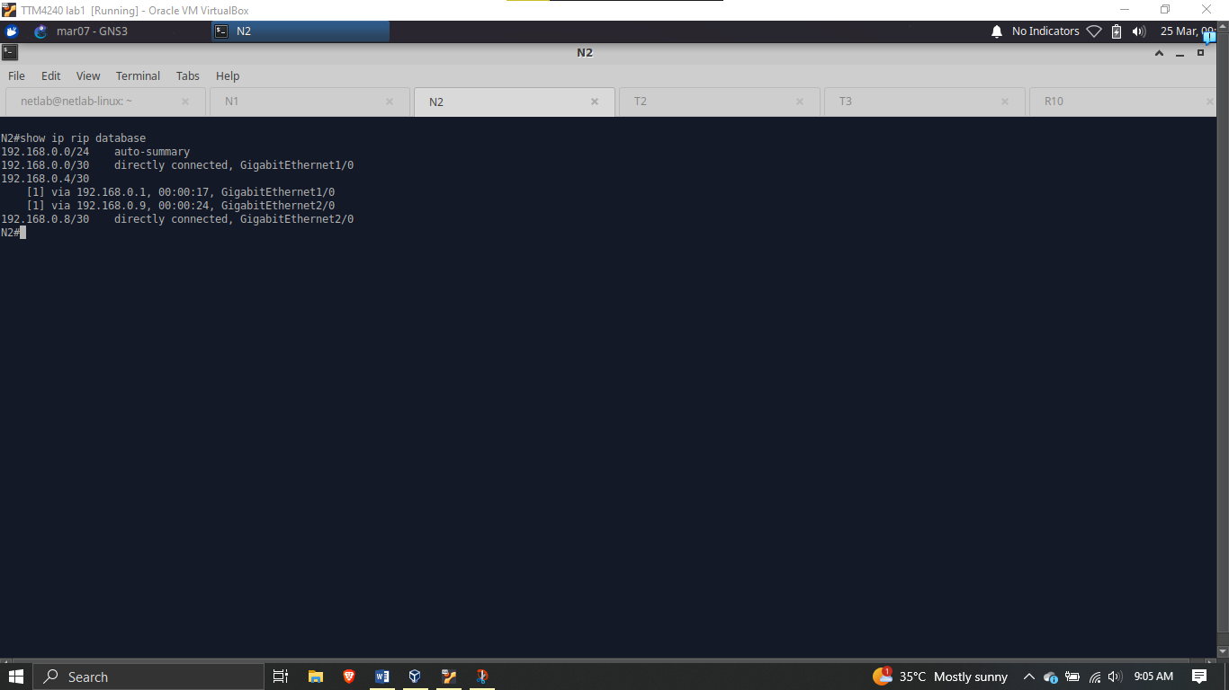

Figure 10: Routing Information Protocol (RIP) Database for Router N2

### **Open Shortest Path First (OSPF)**

OSPF is to be configured for the TeleStar network. Like RIP, OSPF also applies to internal links.

To configure OSPF, the following sequence of commands can be executed in the console of each router.

1. *conf t*
2. *router ospf 1*
3. *network <network ID> <wildcard> area <ospf area number>*
4. *end*
5. *wr*

For router T1 in TeleStar, the command will be as follows:

c*onf t*

*router ospf 1*

*network 172.16.0.0 0.0.0.3 area 0*

*network 172.16.0.4 0.0.0.3 area 0*

*end*

*wr*

To show a given router’s OSPF neighbors, we use the command *<show ip ospf neighbor>*, as shown below.

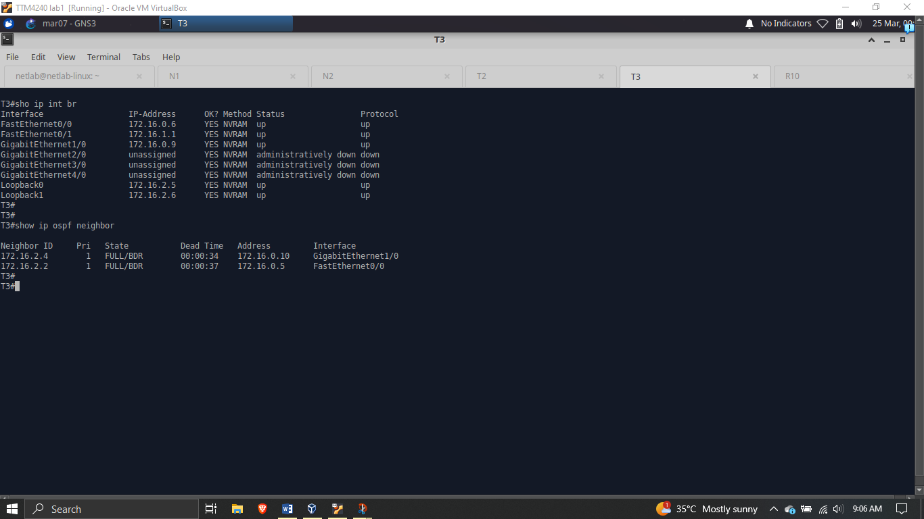

Figure 11: OSPF neighbors for Router T3 after OSPF configuration

### **Border Gateway Protocol (BGP)**

Unlike RIP and OSPF which are confined to a given autonomous system (AS), BGP employs other autonomous systems in its configuration.

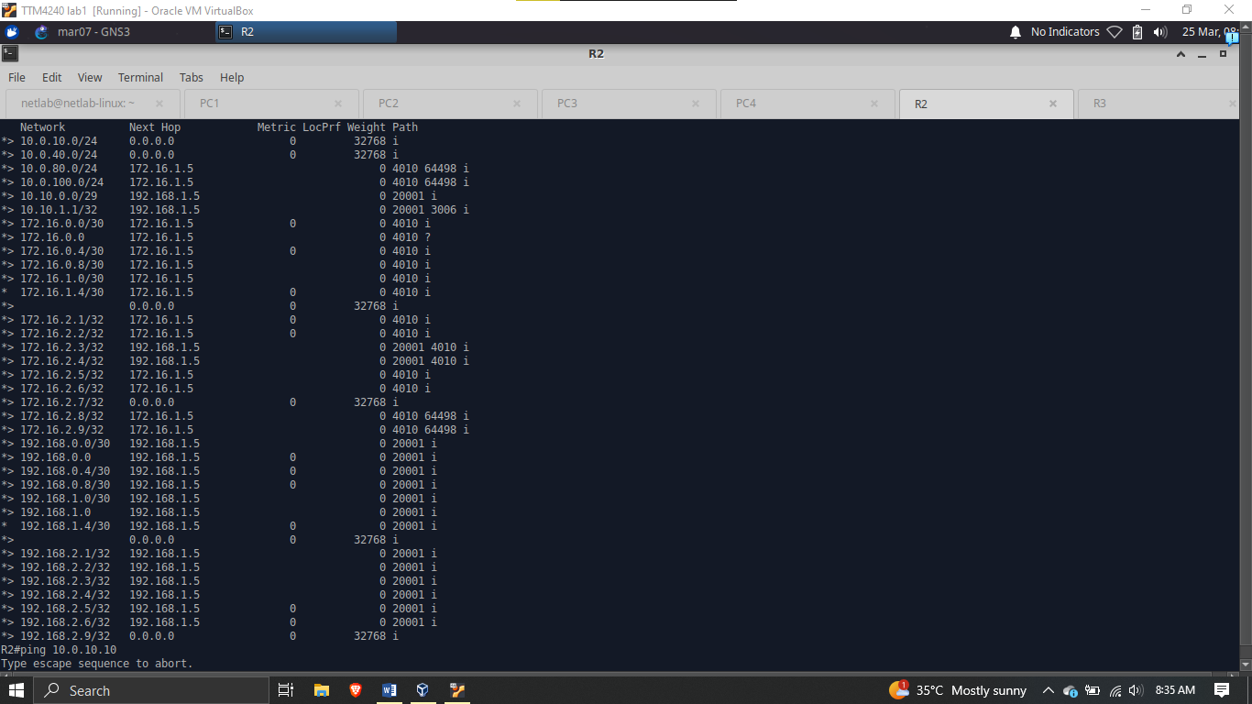

Figure 12: Next Hop BGP information

### **Static Null Configuration**

To perform “injected static Null0 in Level 3 to represent the internet”, the following commands can be followed.

*conf t*

*ip route 0.0.0.0 0.0.0.0 Null0*

*end*

*wr*

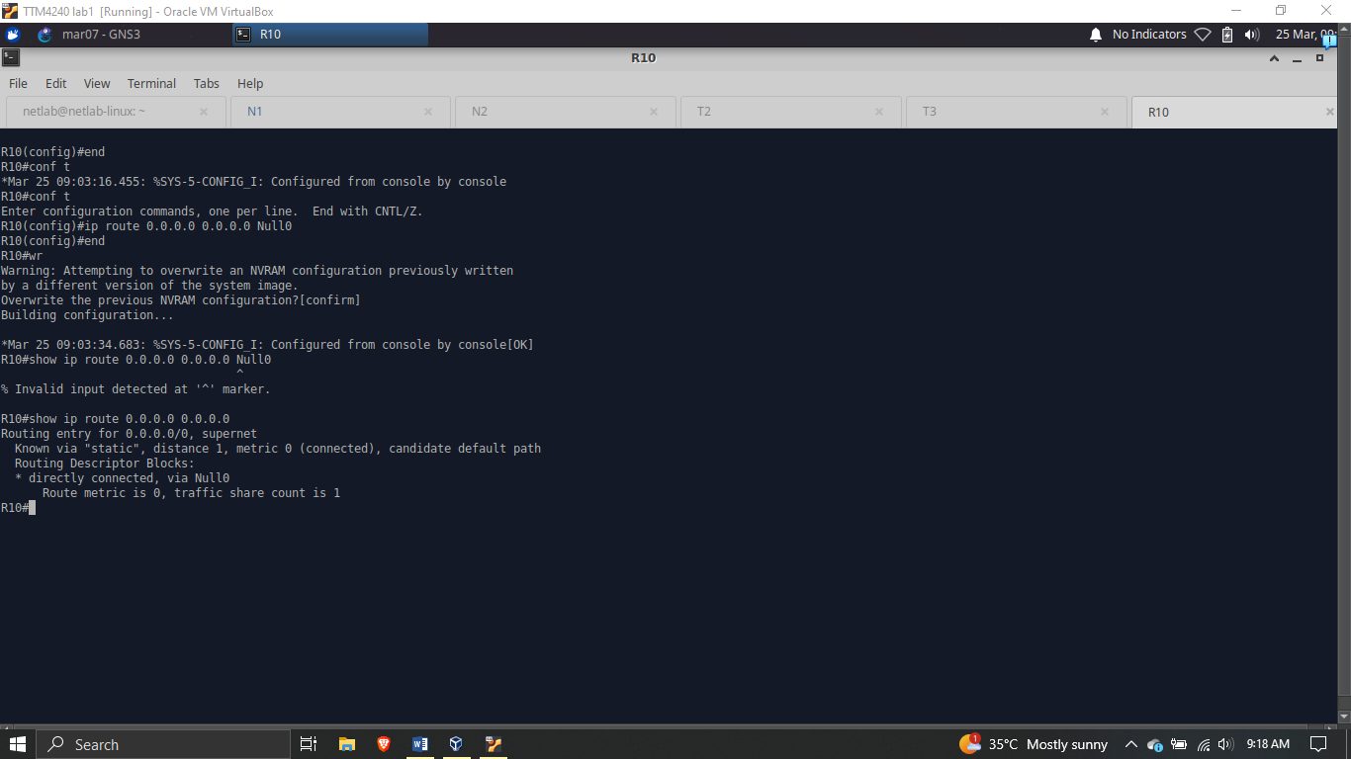

Figure 13: Static Null0 configuration

## **VLAN CONFIGURATION**

To configure VLANs, begin by configuring the Ethernet Switch to match the image below

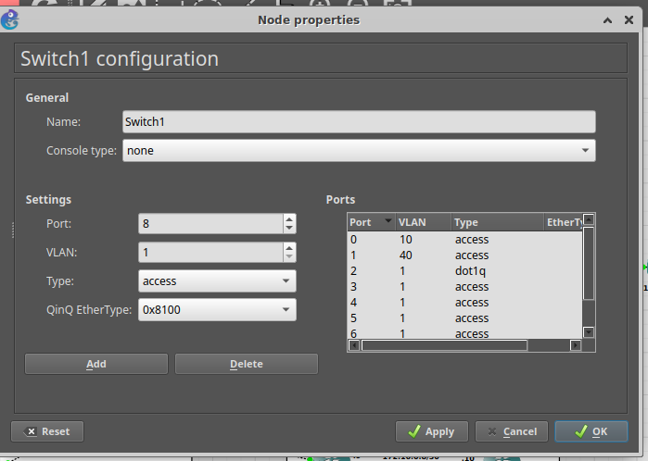

Figure 14: Ethernet Switch Configuration

We are provided with two types of VLANs: VLAN 10 and VLAN 40.

The two VLANs should have different gateways, and also not be able to ping each other (ie. VLAN 10 should not be able to ping VLAN 40)

VLAN Configuration in Router:

*int <interface name, eg. f0/1>*

*no sh*

*int f0/1.10*

*encapsulation dot1Q <VLAN number>*

*ip add 10.0.10.1 255.255.255.0*

*encapsulation dot1Q <VLAN number for next VLAN>*

*ip add 10.0.40.1 255.255.255.0*

*Configuration on PCs:*

*Ip 10.0.10.10/24 10.0.10.1*

Where 10.0.10.10 is the ip address of the virtual PC and 10.0.10.1 is the gateway.

Encapsulation is done to split the interface.

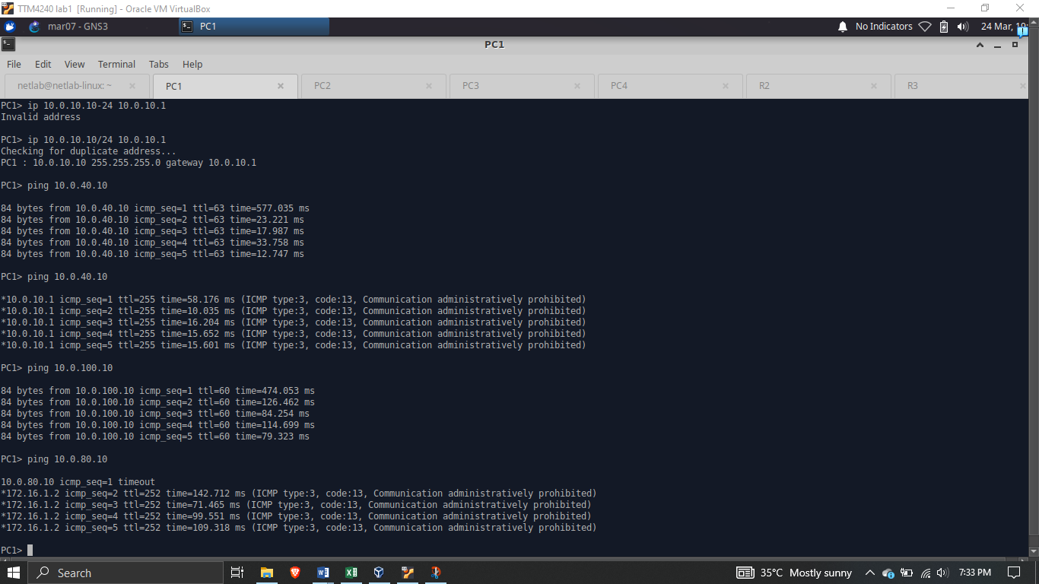

Figure 15: VLAN ping test

## **GigaEthernet Link Preference Setting**

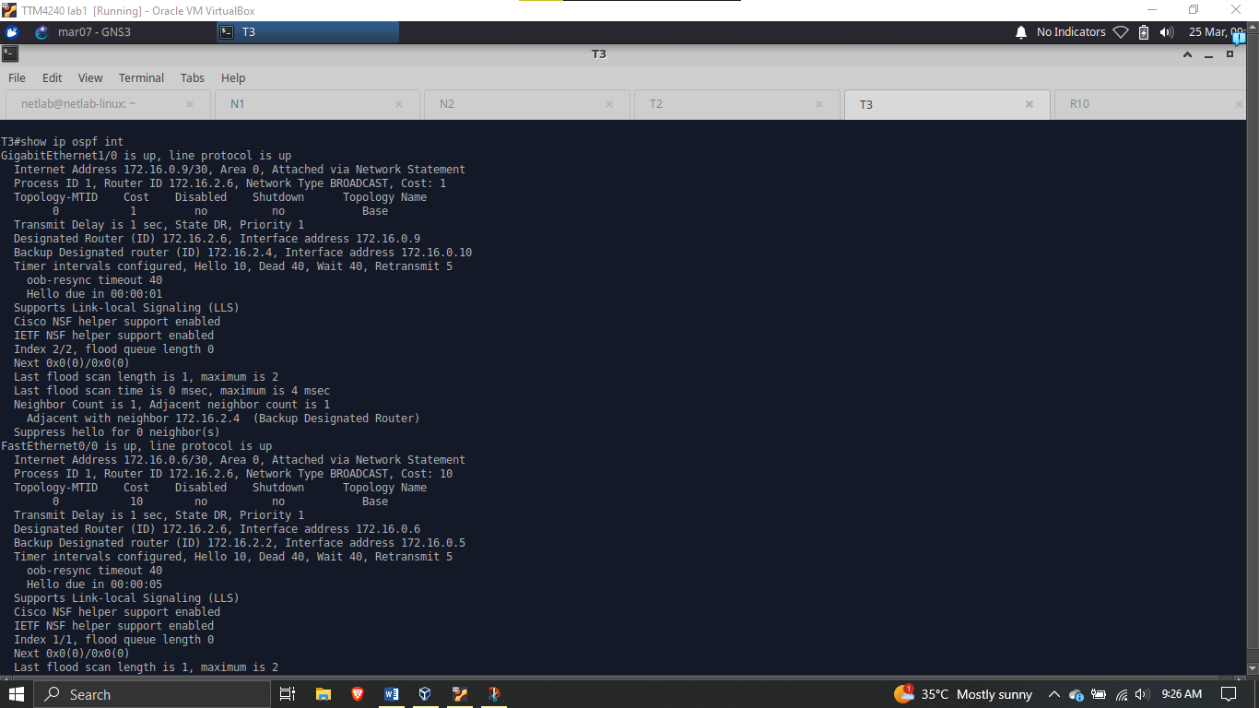

Figure 16: Setting GigaEthernet to be preferred over FastEthernet

## **OSPF Packet Capture**

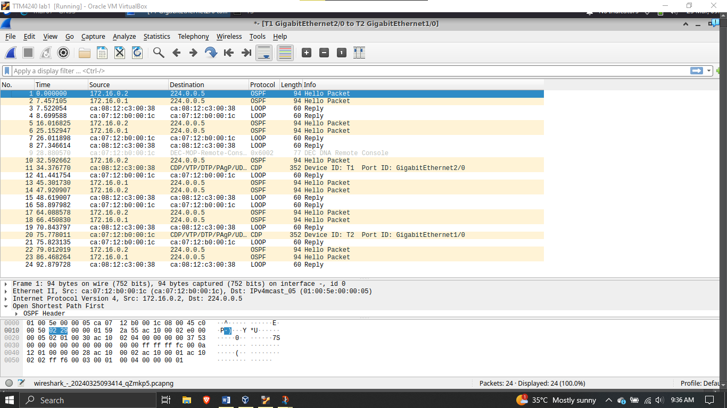

Figure 17: Wireshark OSPF Capture

# **CHAPTER 2: TASK 2 (IPV6)**

## **Introduction**

IPv6 (Internet Protocol version 6) represents the next generation of Internet Protocol designed to address the limitations of IPv4 and accommodate the ever growing demands of the modern internet. With the exhaustion of IPv4 addresses becoming increasingly imminent, IPv6 offers a significantly larger address space, allowing for virtually unlimited unique IP addresses. This expanded address space is crucial for accommodating the proliferation of internet-enabled devices, from smartphones and computers to IoT devices and industrial machinery, ensuring the continued growth and scalability of the internet. IPv6 addresses are represented in hexadecimal notation and consist of approximately 340 undecillion unique addresses.

Additionally IPv6 introduces improvements in addressing, security, and network performance, making it the foundation for future internet connectivity. As organizations and network providers transition to IPv6, understanding its principles and capabilities is essential for network engineers and administrators to ensure seamless integration and continued operation of the global internet infrastructure.

## **Topology Visualization**

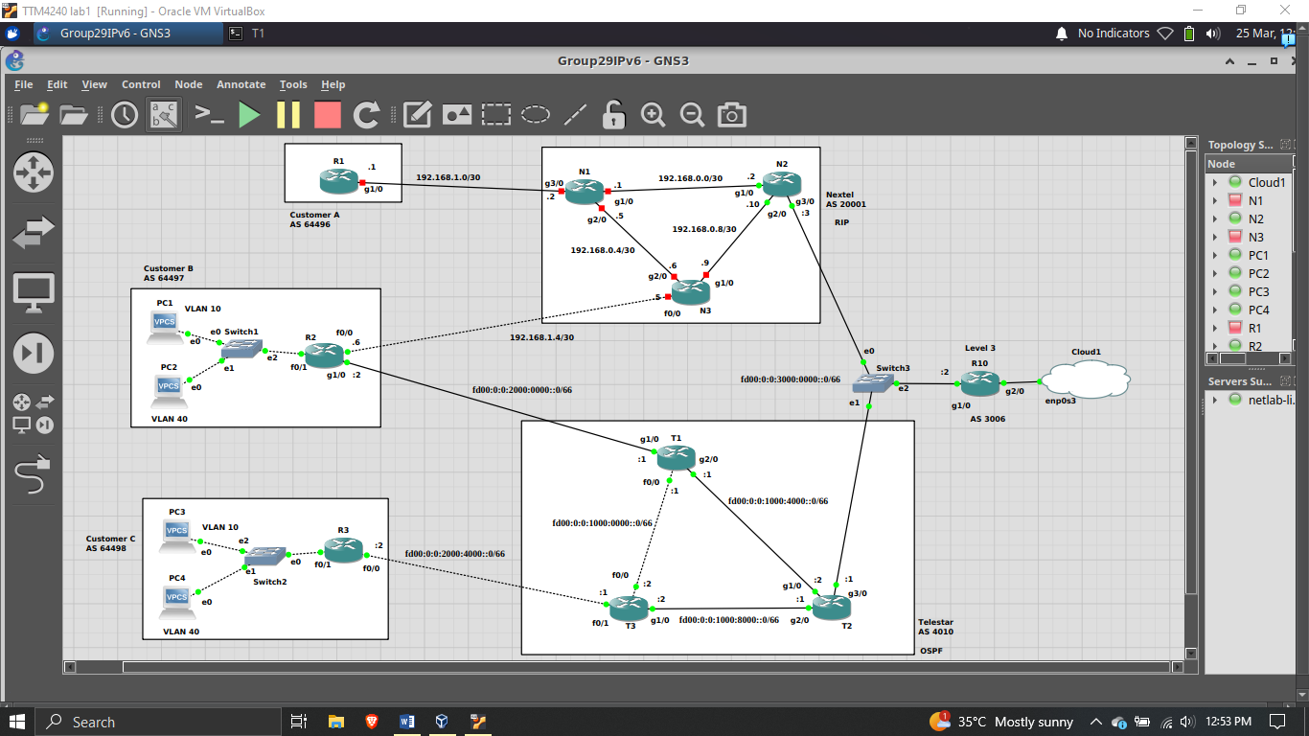

Figure 18: IPv6 Topology Visualization

## **IPv6 Address Planning**

### **Removal of IPv4 Addresses**

Commands:

*conf t*

*int <interface name>*

*no ip address <interface ipv4 address> <interface subnet mask>*

*end*

*wr*

Perform *<show ip interface brief>* to show the IPv4 address for the interfaces of a given router.

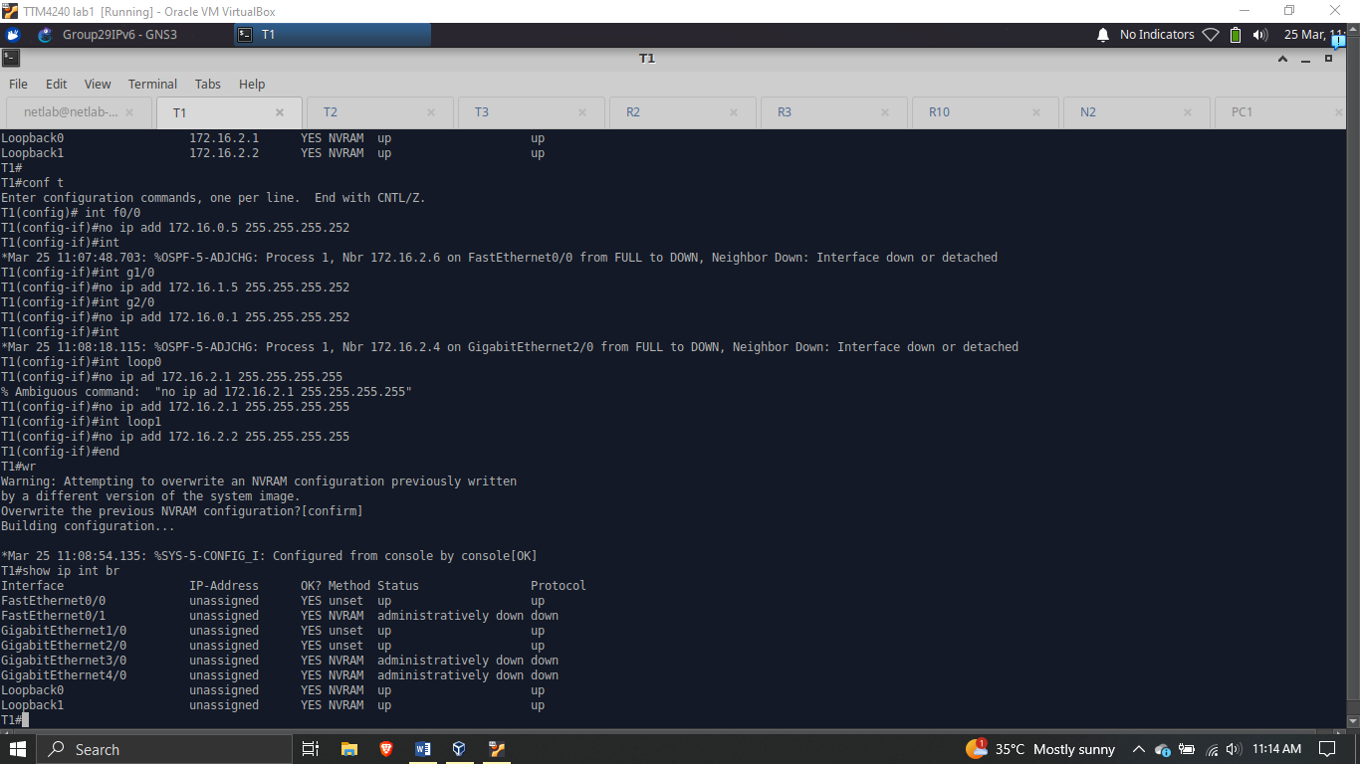

Figure 19: Removal of IPv4 Addresses

### **Assigning IPv6 Addresses**

|  |  |  |  |
| --- | --- | --- | --- |
| **Autonomous System** | **Router** | **Interface** | **IPv6 Address** |
| Customer B (AS 64497) | R2 | g1/0 | fd00:0:0:2000:0002::0/66 |
| Customer C (AS 64498) | R3 | f0/0 | fd00:0:0:2000:4002::0/66 |
| NextTel (AS 20001) | N2 | g3/0 | fd00:0:0:3000:0003::0/66 |
| Telstar  AS 4010 | T1 | Loopback0 | fd00:0:0:4000:0005::0/128 |
| Loopback1 | fd00:0:0:4000:0006::0/128 |
| g1/0 | fd00:0:0:2000:0001::0/66 |
| g2/0 | fd00:0:0:1000:4001::0/66 |
| f0/0 | fd00:0:0:1000:0001::0/66 |
| T2 | Loopback0 | fd00:0:0:4000:0003::0/128 |
| Loopback1 | fd00:0:0:4000:0004::0/128 |
| g1/0 | fd00:0:0:1000:4002::0/66 |
| g2/0 | fd00:0:0:1000:8001::0/66 |
| g3/0 | fd00:0:0:3000:0001::0/66 |
| T3 | Loopback0 | fd00:0:0:4000:0001::0/128 |
| Loopback1 | fd00:0:0:4000:0002::0/128 |
| g1/0 | fd00:0:0:1000:8002::0/66 |
| f0/0 | fd00:0:0:1000:0002::0/66 |
| f0/1 | fd00:0:0:2000:4001::0/66 |
| Level 3 AS 4010 | R10 | g1/0 | fd00:0:0:3000:0002::0/66 |
| g2/0 |  |
| Loopback0 | fd00:0:0:5000::4001/128 |

Table 4: IPv6 Address Planning

Configuration Commands:

*conf t*

*int <interface name>*

*ipv6 address <ipv6 address>/<prefix>*

*no shutdown*

*exit*

*end*

*wr*

To confirm that IPv6 addresses have been respectively assigned, enter *<show ipv6 interface brief>*. The image below shows these commands in action.

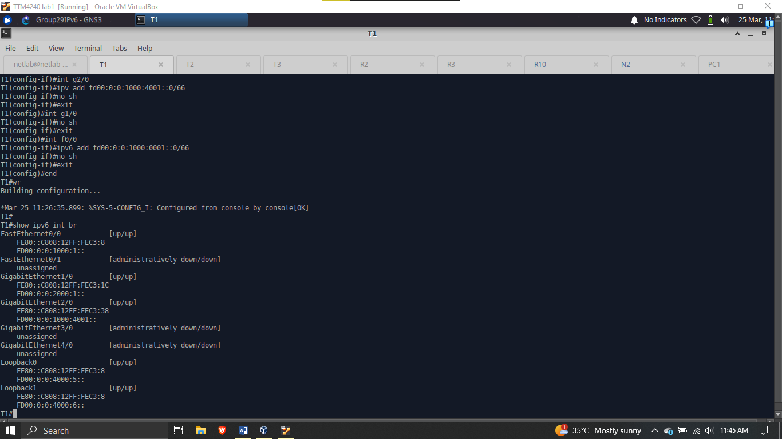

Figure 20: IPv6 Interface Address Configuration for Router T1

### **Level 3**

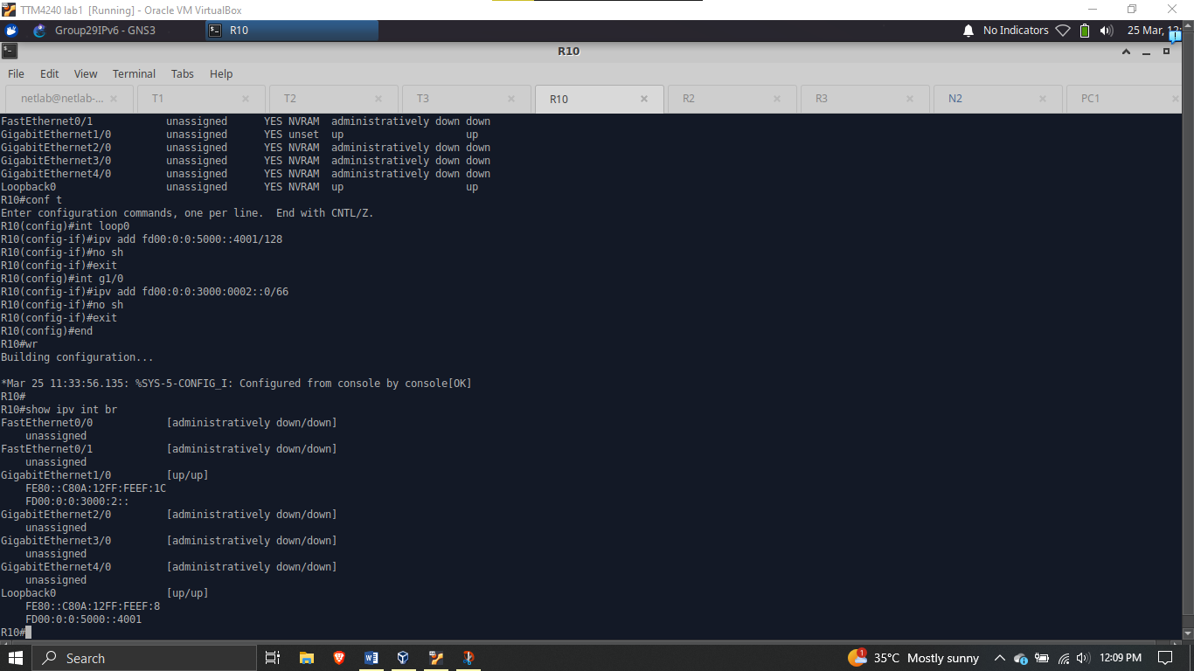

Figure 21: Level 3 Router, R10, Interface Address and Loopback Configuration

## **IPv6 Routing Protocol Configurations**

### **Open Shortest Path First**

Configuration Commands:

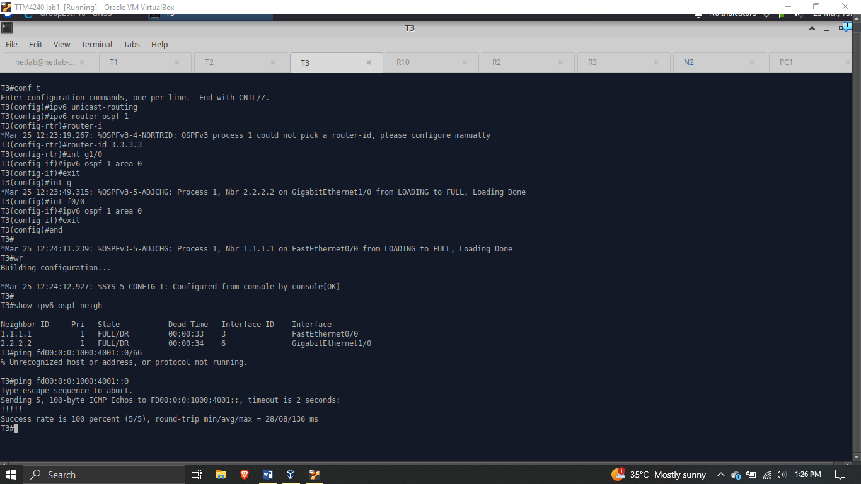

Figure 22: OSPF Configuration for Router T3



Figure 23: Router, T3, OSPF neighbors and ping test

To confirm the router has learnt about other networks through OSPF, we can enter the command *<show ipv6 route>* to show the other addresses in the routing table, as seen below.

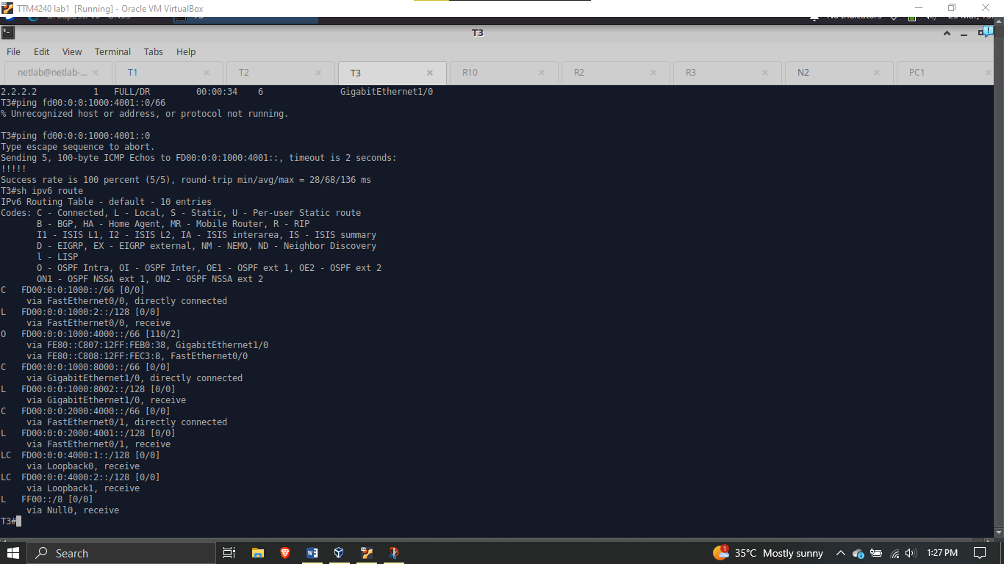

Figure 24: Routing Table Showing OSPF Address for T3

#### GigaEthernet Link Preference

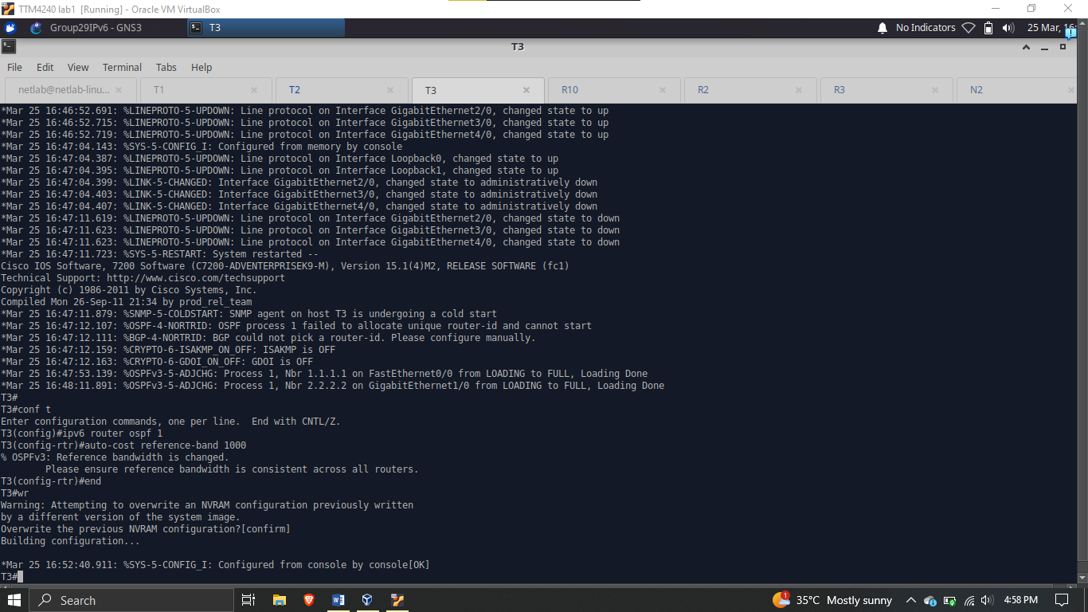

Figure 25: OSPF GigaEthernet Link Preference Configuration

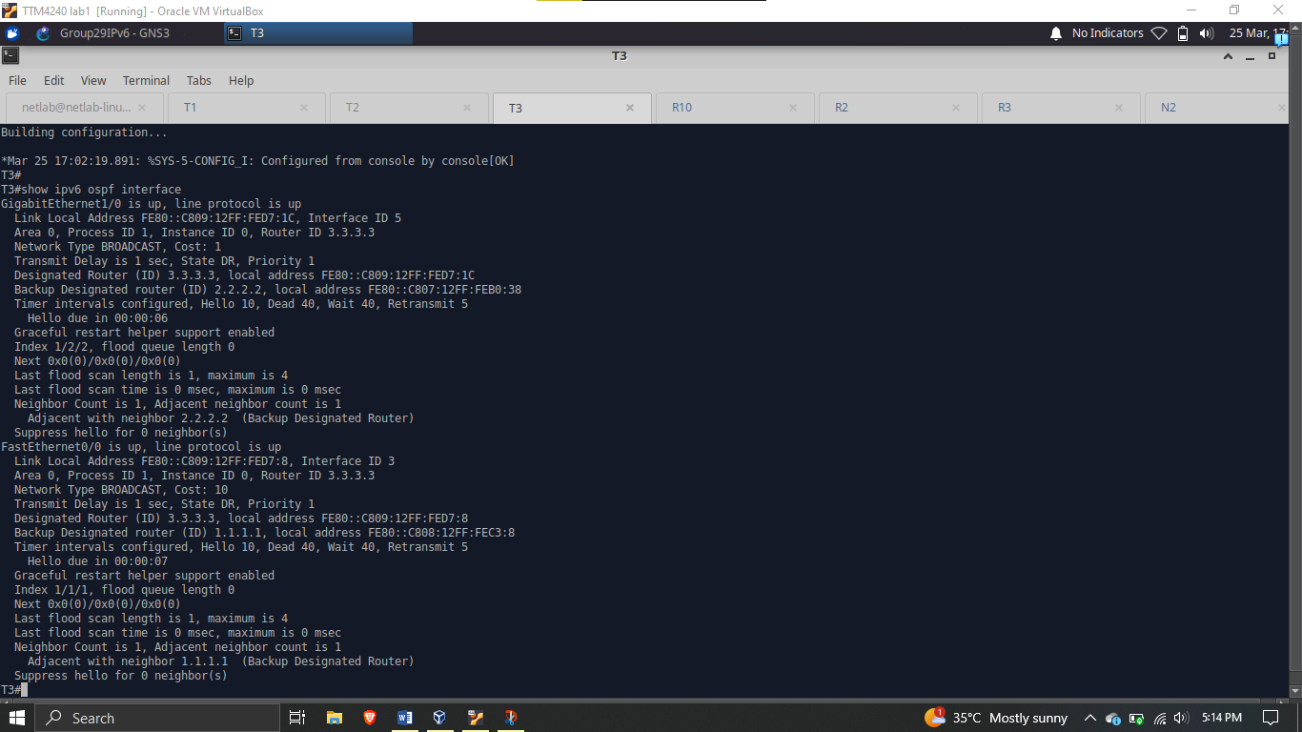

Figure 26: GigaEthernet and FastEthernet Link Costs

### **Border Gateway Protocol**

**Configuration Commands:**

*conf t*

*ipv6 unicast-routing*

*router bgp <AS number>*

*no bgp default ipv4*

*bgp route-id <router id>*

*neigh <neighbor interface address> remote-as <AS number of remote AS>*

*address-family ipv6*

*neigh <address of neigh interface> activate*

*network <network ID to be advertised>*

*end*

*wr*

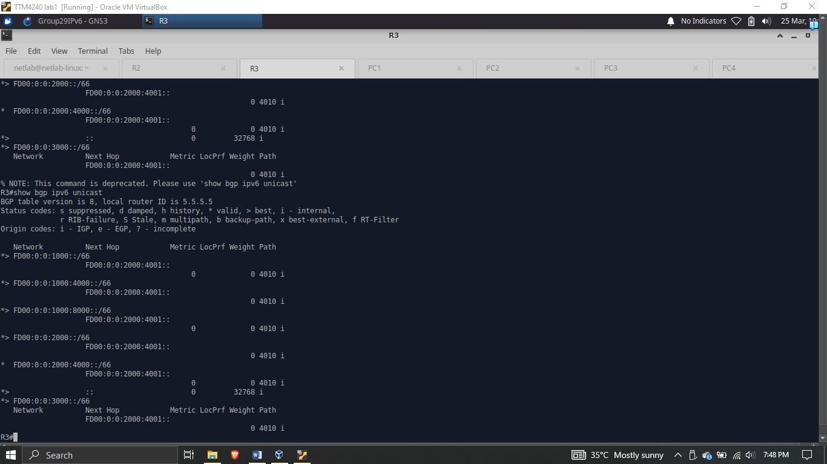

Figure 27: BGP Next Hop and Neighbor information

## **Tunneling**

*conf t*

*int tun 0*

*ip address <unsued ipv4 address>*

*tun source <router interface name>*

*tun dest <ipv6 address of destination interface>*

*tun mode gre ipv6*

*exit*

*ip route 10.0.10.10 255.255.255.0 tunnel 0*

*ip route 10.0.40.10 255.255.255.0 tunnel 0*

*end*

*wr*

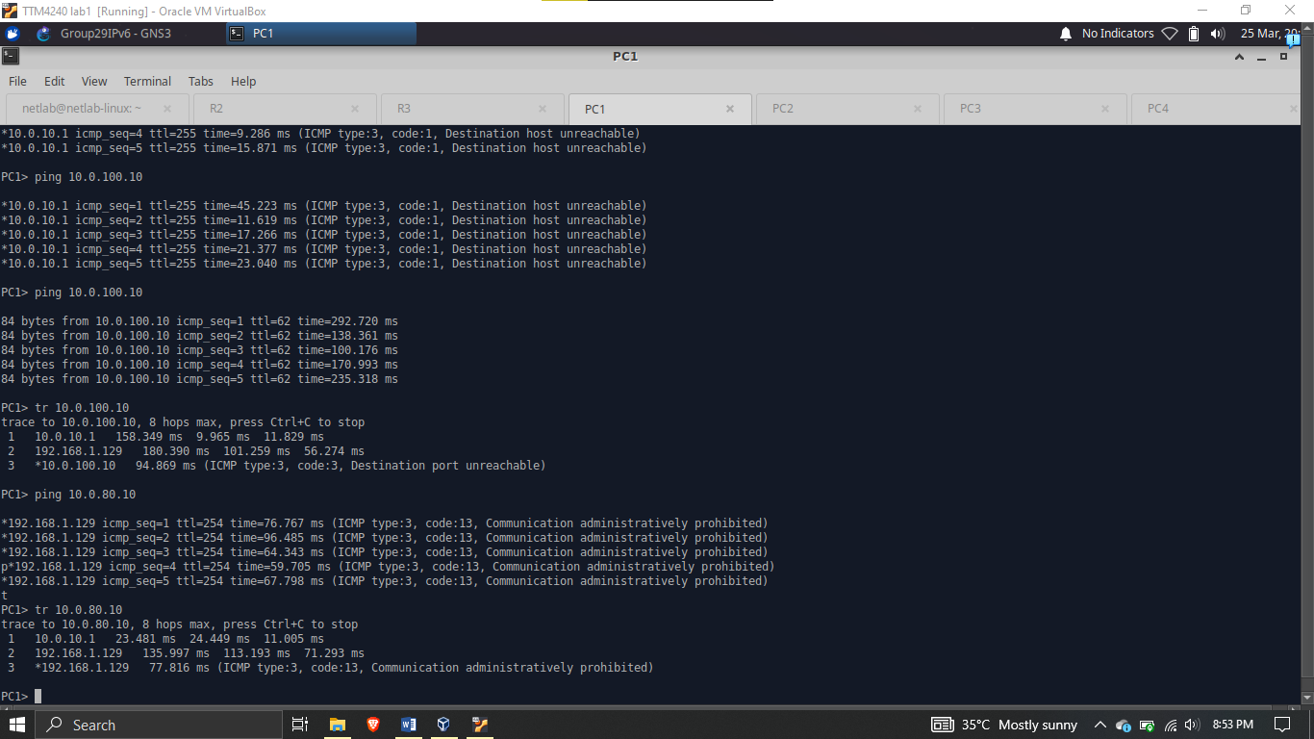

Figure 28: Ping and Traceroute test for tunneling on PC 1

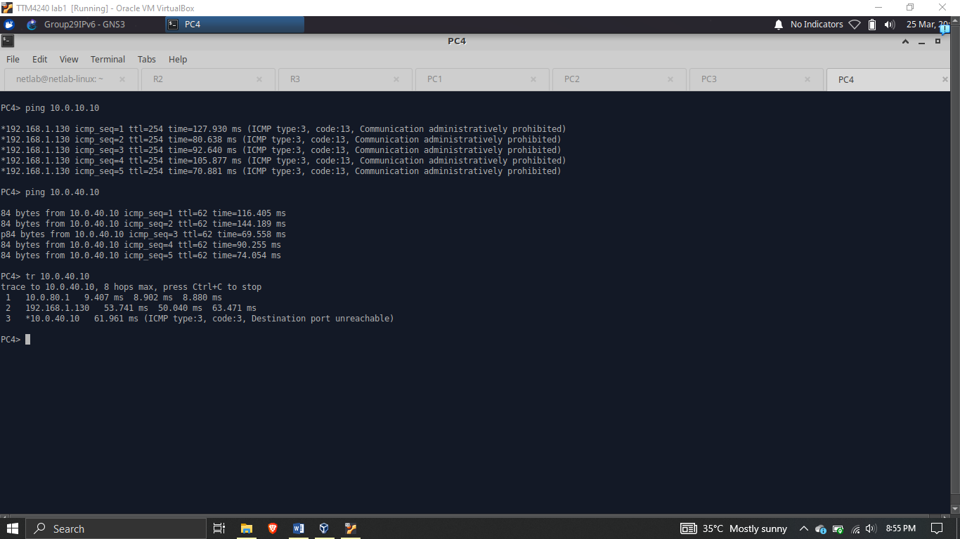

Figure 29: Ping and Traceroute test for tunneling at PC4